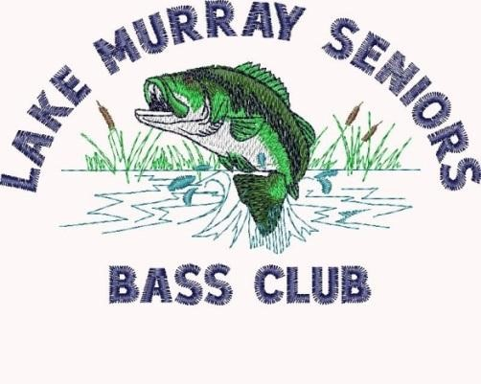
DECEMBER 2014
Business Meeting
The meeting was held on the 10th at Macedonia Church. There were 42 members in attendance. David Larrabee presided over the meeting.

- Fifty-Fifty Drawing was held.
- There was a discussion concerning the excess boaters wording in our By-Laws. It was decided to change the wording from will to may be paired with another boater.
- David had with him things that the club owns, i.e., a water jug, megaphone, and plaques which have been retired. It was decided that the water jug and the megaphone will be given away and the plaques were presented to two club members.
- The spending budget for the banquet was discussed. It was decided to recognize the top five in each category as well as the Big Fish and Big Bag of the year. Money will be given to each.
- It was brought up what we will do in case of a tie for the champions. This has occurred once before and we recognized each of the members as co-champions.
- Dave Slaughter was at the hospital during our meeting to have a procedure done on his prostrate cancer. Also, after several months away, Mike Bailey was at the meeting and will be fishing.
- The January One-on-One will be held on the 8th, fishing from 8:00 to 3:00.
- The December One-on-One was won by Tom Weigand with 5 fish weighing 10+ pounds.
- Sam Gray rendered our blessing and lunch was served.
- Our December Tournament pairings were accomplished. There will be 20 boaters and 14 no-boaters fishing from 8:30 to 3:30. Five boaters decided to each fish alone.
- The meeting was adjourned.

Next meeting is the Banquet on January 10th
@ 6:00 p.m. @ Macedonia Church.
Menu will be fried chicken and BBQ, macaroni & cheese, green beans, dessert, rolls and tea. Cost is $12.00 per person.

Tournament Results
Our December tournament was held on the 11th out of Billy Dreher State Park and 33 members participated. Nineteen boats departed at 8:30 am with weigh-in scheduled for 3:30 pm. The results were 51 fish caught at an approximate weight of 118 pounds. There were 3 limits caught with 2 teams that were skunked. There were no dead fish. For those with computer access please see the Tournament results posted on the web site. For those without computer access please see the attached print out for those results.

1st Place
Randy Fulmer and Earl Greenaway 14.60 lbs.

Big fish

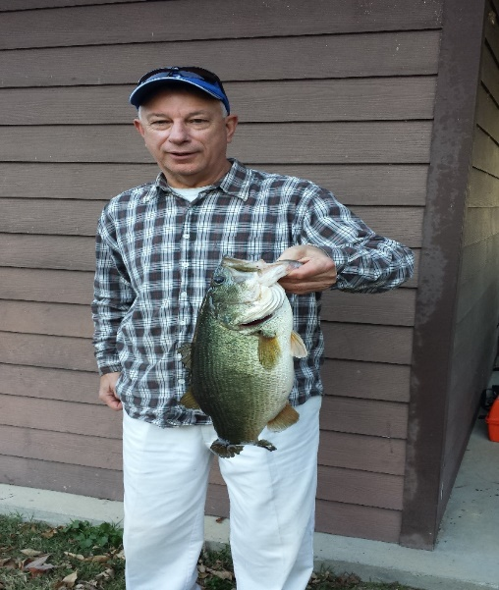
Steve Wicker 7.65 lbs.

Congratulations!!!
Next Tournament is January 15th.

2015 LMSBC Awards Banquet
The Banquet will be held on January 10, 2015 at Macedonia Church at 6:00 p.m. Doors will open at 5:00 p.m. The menu is Fried Chicken and BBQ, macaroni & cheese, green beans, cole slaw, dessert, rolls and tea. The cost of the banquet is $12.00 per person. If you wish to attend and have not yet signed up, please give David Larrabee a call so we can give John Matthews an accurate count for the number of meals. You can pay for the meals at the door. Two tickets will be available. One is for the raffle and one is for door prizes. Only club members will be eligible for the door prizes. Also, dues and January fishing can be paid. Further, insure you have signed up as a boater or non-boater. If you can help with set up, please be at the church at 10:30 a.m.

TOURNAMENT DIRECTOR NEWS

Tom Weigand will be taking over as the Tournament Director in January 2015. Thanks to him for doing this job. Also, much thanks to Jim Wimmer for an outstanding job as the “Director” for the last two years. We appreciate your faithfulness and fun approach to the position.

November Tournament News
First Place: Jimmijo Matthews, 5 Fish, 16.65 pounds on crank baits.
Second Place: Skip Parker and Larry Black, 5 Fish, 13.45 pounds on worms.
Third Place: Jim Edwards and Eddie Sloop, 5 Fish, 10.85 on shaky heads.
Fourth Place, Earl Purcell and Burl Fleming, 3 Fish, 10.80 on crank baits.
Fifth Place: Marvin Brown and Carl Horn, 4 Fish, 9.15 pounds on worms.

January One-on-One will be on the 8th fishing 8:00 until 3:00.

Bargain Corner
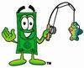

CLUB HATS, SHIRTS, AND JACKETS
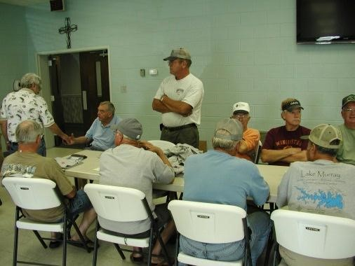
Sammy Crouch is the man to see! He has hats available and can make arrangements for shirts, jackets, and embroidery. If you are interested in a club T-Shirt, light gray with club logo on the front and Lake Murray on the back, give Sammy a call @ 803808-6133 or 864-992-0529.

NEED REPAIRS
Earl Greenaway has all the parts to repair Minn Kota and Motor Guide Trolling Motors. He also does reels and rods. Give Earl a call at 796-1262 or 509-2806 (Cell).

Lake Murray Seniors Bass Club www.lakemurrayseniorsbassclub.com
Jim Cushman
803-360-4350
424 Charles Kneece Road
Charles Kneece Road
Leesville, S.C. 29070

