**LAKE MURRAY SENIORS BASS CLUB**

**January 2012**

**2011 Boater Champion**

**Randy Fulmer**

**2011 Non-Boater Champion**

**Joe Fleming**

**2011 Big fish of the year**

**Jim Safley**

**7.59 lbs.**

**2011 Big bag of the year**

**Randy Fulmer and Jim Safley**

**19.67 lbs**

**Top ten anglers**

|  |  |  |
| --- | --- | --- |
|  | **Boater** | **Non-Boater** |
|  | **Randy Fulmer** | **Joe Fleming** |
|  | **Bud Dalton** | **Jim Safley** |
|  | **Sammy Crouch** | **Tom Weigand** |
|  | **Charlie Smith** | **Mike Bailey** |
|  | **Bob Kramer** | **Clint DeBrand** |
|  | **Dave Slaughter/David Larrabee** | **Burl Fleming** |
|  |  | **Dave McClintic** |
|  | **Ron Wood** | **Roger Isaac** |
|  | **Bill Lee** | **Sam Drake** |
|  | **Skip Parker** | **Ed Kelly** |

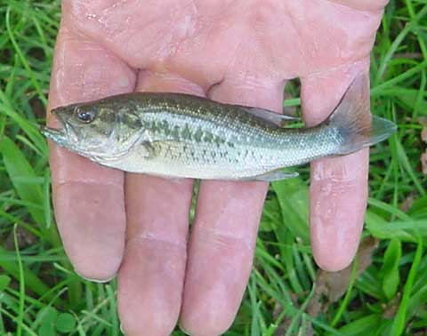**Very special trophy for Smallest Bag of the year**

**Sam Gray and Marion Maner**

**1.10 pounds**

**JANUARY BUSINESS MEETING**

The meeting was held as part of the Awards Banquet on the 14th at Macedonia Church. There were 53 members in attendance and 43 guests. Our president, David Larrabee, presided over the meeting.

* A 50/50 raffle was held and Ron Wood was the winner.
* David told some hilarious Earl Greenaway stories!!!
* David offered a special thanks to those individuals that were responsible for getting door prizes for the banquet.
* The new members that were present, Jimmy Wheeler and John Anderson were recognized and welcomed to the club.
* Dave Slaughter, Willie Crocker, Joe Fleming and James Fulmer were thanked for the help they have provided in different capacities.
* Schedule for upcoming events is: One on One, February 9th; Tournament, February 16th.
* The 2011 year in review. Average of 26 boats with 51 members which is up from (2010). 1067 (931) fish weighing 1926 (1764) pounds with an average of 1.80 (1.89) pounds per fish.
* Released 96% (97%) of fish alive.
* April was one of the better months 57 members, 29 boats, and 112 fish weighing 236 pounds. May had 60 members, 111 fish weighing 219 pounds.
* January was the worst: 46 members, 55 fish, 130 pounds and only 5 limits and 6 didn't catch a fish.
* December Tournament Winners were recognized.
* Individual with perfect attendance at all meetings and tournaments were recognized.
* The monthly tournament winners were recognized.
* Special Club Awards were presented. Jock received a plaque for the service he provided to the club during the year. Jim Cushman was presented a Club Jacket for his service as President and Secretary. Ed Kelly was announced as the new Secretary.
* Top Ten Anglers of the year along with the appropriate awards were recognized.
* David and Jock Prestigiacomo then conducted the draw for our January Tournament.
* The meeting was adjourned.

A great time was had by all at the Annual Banquet!!!!!

**Tournament Director News**

The next “one on one” will be held on February 9th from 7:30am —2:30pm.

Remember to check “Breaking News” on the club web site for changes.

Please bring some change for the entry fee; i.e., two 10’s or a 10 and two 5’s.

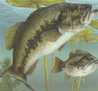Rules for the “one on one”:

* Tournament fee is $20 per person of which $5 goes to Big Fish.
* A seven hour tournament starting at Safe Light or time designated by the TD.
* If you fish with a partner, fish must be separate at all times.
* If you come in late, you are disqualified.
* A quarter pound penalty per dead fish.
* A pound penalty for a short fish.

Pay out is as follows: 1—9 participants, 100%; 10—15 participants, 60% and 40%;

16 participants and over, 50%, 30%, and 20%.

**Tournament Results**

Our January 2012 tournament was held on the19th out of Billy Dreher State Park and 48 members participated. Twenty four boats departed at 8:00am with weigh-in scheduled for 3:00pm. It was a very chilly morning and there was a cold wind most of the day. The results were 66 fish caught at an approximate weight of 145 pounds. There were seven limits caught with four zeroes. There were no dead fish. For those with computer access please see the Tournament results posted on the web site. For those without computer access please see the attached print out of those results.



Mums the word! Ron’s not giving his secrets away!!!!!

Congratulations!!!

**Next Tournament is February 16th**

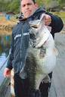

**FISH TRIVIA**

**What’s South Carolina’s Largemouth Bass Record and when was it caught????**

**Check next month’s issue for the answer.**

**Next meeting is on February 15th @ 11:00 a.m.**

**@ Macedonia Church.**



Menu will be country ham, grits, scrambled eggs, sliced tomatoes and rolls. Cost is $8.00 per person.

**Bargain Corner**

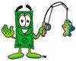

In the future I plan on including any information the members are willing to share on the deals or specials they have found on fishing equipment, boat supplies, store sales, discounts offered etc. I would also like to include a tip of the month that might help other members. So if there is anyone out there willing to do that please email me or tell me what they are so I can include that information in the future. My email address is kellyev@sc.rr.com or call me on my mobile phone at 803-381-6206. Thanks!!!

The only thing I have for this month is that Sportsman Warehouse has a $10 coupon on the back of the old fishing regulations. You have to spend at least $100 to use. A couple of members could go together to get to $100. They have them at the customer service counter. The coupons show a December expiration date but are still being accepted by the store. I used one yesterday.

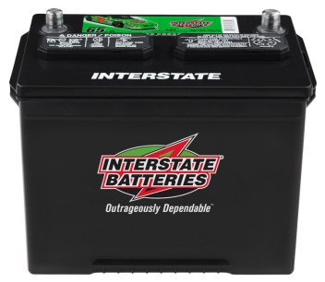

**INTERSTATE BATTERIES**

Buddy’s Marine is making batteries available only to our bass club for the following prices:

24 MXHD—$79.95 SRM 27—$82.95 27 MXHD—$89.95

199 W Hwy 378, Lexington, SC 29072 803-957-FISH

C:\Users\Owner\AppData\Local\Microsoft\Windows\Temporary Internet Files\Content.IE5\OF3DFDOW\MC900330050[1].wmf**CLUB HATS, SHIRTS, AND JACKETS**

Sammy Crouch is the man to see! He has hats available and can make arrangements for shirts, jackets, and embroidery. If you are interested in a club T-Shirt, light gray with club logo on the front and Lake Murray on the back, give Sammy a call @803-808-6133 or 864-992-0529.

http://mk.factoryoutletstore.com/images/new_fos/leftbar_logos/173/logo.gif**NEED REPAIRS**

Earl Greenaway has all the parts to repair Minn Kota and Motor Guide Trolling Motors. He also does reels and rods. Give Earl a call at 796-1262 or 509-2806 (Cell).

Lake Murray Seniors Bass Club

Www.lakemurrayseniorsbassclub.com

Ed Kelly

695 Newberry Shores Dr

Prosperity, S.C. 29169